**Northeastern Illinois University**

2014

**Database Document**

**Timesheet & Leave Management System**

Anusha Bestha

Jyoti Behera

Lakshmi Vasundhara Tammisetty

Sumanth Tadikonda

Sushma Adepu

DOCUMENT RELEASE NOTICE

**Document Details:**

|  |  |  |
| --- | --- | --- |
| **Name** | **Version No.** | **Description** |
| Database Document | 1.0 | This document for **Timesheet & Leave Management System** Of **Northeastern Illinois University** includes instructions for creating schema and database tables of the system. |

**Revision Details**

|  |  |  |  |
| --- | --- | --- | --- |
| **Action taken**  **(Add/Del/Change)** | **Preceding Page No.** | **New Page No.** | **Revision Description** |
|  |  |  |  |
|  |  |  |  |
|  |  |  |  |
|  |  |  |  |
|  |  |  |  |

Table of Contents

1 Introduction: 4

1.1 Purpose of the document: 4

1.2 Definitions, Acronyms, and Abbreviations 4

1.3 References 4

2 Getting Started 5

2.1 Instructions to create database schema using MySql Workbench 5

2.1.1 Preconditions: 5

2.1.2 Steps to create schema: 5

2.2 Instructions to create tables using MySql Workbench 5

2.2.1 Preconditions: 5

2.2.2 Steps to create schema: 5

2.2.3 List of tables need to be created for T&L system 5

# Introduction:

The Software Design Document is a document to provide documentation which will be used to aid in software development by providing the details for how the software should be built.

## Purpose of the document:

The purpose of the TLS Software Design Document is to provide a description of the design of a TLS system fully enough to allow for software development to proceed with an understanding of what is to be built and how it is expected to built. The Software Design Document provides information necessary to provide description of the details for the software and system to be built.

Within this Software Design Document are narrative and graphical documentation of the software design for the TLS project including use case models, sequence diagrams, and other supporting requirement information of TLS system.

## Definitions, Acronyms, and Abbreviations

This section provides a list of the acronyms and abbreviations used in this document and the meaning of each.

|  |  |
| --- | --- |
| **Definitions/Acronyms/Abbreviations** | **Meaning** |
| TLS | Timesheet & Leave Management System |
| T&L | Timesheet & Leave |
| Entities | Any real world thing is an entity. Each table is an entity. |
| Attribute | The properties that describe an entity are called an attributes. Columns of each table are attributes. |
| Primary Key | An attribute or column in an entity that is used to uniquely identify the rows in that entity. |

## References

Below is the list of the references that were used in preparation of this document in order of importance to the end user

1. Timesheet & Leave Management System_SRS.doc
2. T&L System Design Document.docx

# Getting Started

## Instructions to create database schema using MySql Workbench

### Preconditions:

* MySql server is installed and configured.
* MySql Workbench is installed.

For installation instructions, check the below mentioned documents in the github:

* T&L build Insturctions.docx
* T&L UserManual.docx

### Steps to create schema:

* Below link describes the steps to create a schema using Mysql Workbench

<http://dev.mysql.com/doc/workbench/en/wb-getting-started-tutorial-creating-a-model.html>

* Schema name for T&L System : “test”

## Instructions to create tables using MySql Workbench

### Preconditions:

* Schema ‘test’ is created in your server.

### Steps to create schema:

* Below link describes the steps to create a database and adding tables to the database using Mysql Workbench

<http://dev.mysql.com/doc/workbench/en/wb-getting-started-tutorial-adding-data.html>

### List of tables need to be created for T&L system

#### Login:

#### This table stores the username, password and security question and answer details of a particular user which are used for logging into the system.

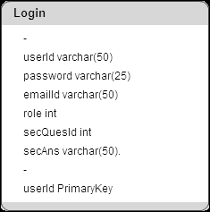

##### Create Statement for Login Table:

Create table login(userId varchar(50) primary key,

password varchar(25) not null,

emailId varchar(50) not null,

role int not null,

secQuesId int not null,

secAns varchar(50) not null);

#### Student Profile:

This table stores all the student worker personal and job related information which are added by manager of that student. It also stores the activation status of the student.

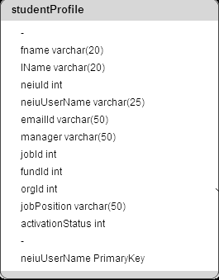

##### Create Statement for studentProfile Table:

Create table studentProfile( fname varchar(20),

lName varchar(20),

neiuId int,

neiuUserName varchar(25) primary key,

emailId varchar(50),

manager varchar(50),

jobId int,

fundId int,

orgId int,

jobPosition varchar(50),

activationStatus int );

#### Timesheet:

This table stores the number of hours entered by a student for each day of a week for two weeks and also the status of timesheet whether it is approved or rejected by the manager along with his comments.

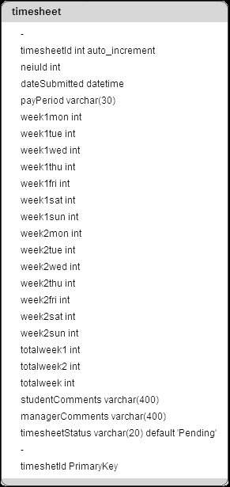

##### Create Statement for timesheet Table:

Create table timesheet(timesheetId int NOT NULL primary keyAUTO_INCREMENT

neiuId int,

dateSubmitted datetime,

payPeriod varchar(30),

week1mon int,

week1tue int,

week1wed int,

week1thu int,

week1fri int,

week1sat int,

week1sun int,

week2mon int,

week2tue int,

week2wed int,

week2thu int,

week2fri int,

week2sat int,

week2sun int,

totalweek1 int,

totalweek2 int,

totalweek int,

studentComments varchar(400),

managerComments varchar(400),

timesheetStatus varchar(20) default 'Pending');

#### User Leave:

This table stores the leave request details raised by a student like from date, to date, reason for leave, status of approval of leave and manager comments

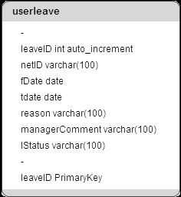

##### Create Statement for userleave Table:

Create table userleave (leaveID int NOT NULL AUTO_INCREMENT,

netID varchar(100),

fDate date NOT NULL,

tdate date NOT NULL,

reason varchar(100) not null,

managerComment varchar(100),

lStatus varchar(100),

PRIMARY KEY (leaveID));

#### Security:

#### This table stores the list of security questions that are assigned to a user which is used for authenticating the user when they forget password.

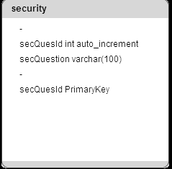

##### Create Statement for security Table:

Create table security(secQuesId int auto_increment primary key,

secQuestion varchar(100));

#### Jobs:

This table stores the list of jobs and their details like fund id, org id that can be assigned to student worker by his manager.

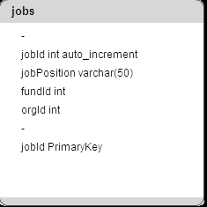

##### Create Statement for jobs Table:

Create table jobs (jobId int auto_increment primary key,

jobPosition varchar(50),

fundId int,

orgId int);

#### Paycal :

This table stores the list of dates for pay period used for submitting timesheets.

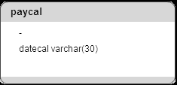

##### Create Statement for jobs Table:

Create table paycal ( datecal varchar(30) );